Fig. 12(a) data: The pie chart presented in Figure 12(a) is generated using values calculated from experimental data
Power loss distribution
Parameter | Loss (w)
S1 | 1.23
S2 | 1.4
S3 | 3.5
T1 | 0.8
T2 | 0.6
T3 | 0.65
T4 | 0.9
L | 0.3
C1 | 0.08
C2 | 0.09

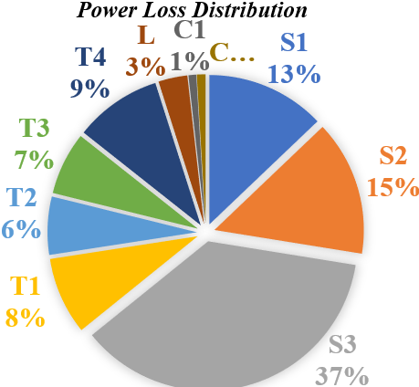

Fig. 12(b) data: The efficiency plot presented in Figure 12(b) is generated using values calculated from experimental data.

figure;
%plot(P, EF, 'r', 'LineWidth', 2.5);
hold on;
x1=[ 190.05 205 217.15 233.34 253.4 276.37 304.01 337];
y1=[ 92.13 93.09 93.008 92.5 92.8 92.66 92 91.2];
plot(x1,y1,'o-','LineWidth',2)
ylim([80 100]);
xlabel('Output Power (W)');
ylabel('Efficiency (%)');
title('Efficiency vs Output Power');
grid on;
box on;

